Entering Leads into Pipedrive

Important notes:
- The highlighted fields are MANDATORY.
- Only ONE NAME for contact person. i.e. if Jill & Joe Blogs are the client, enter Jill Blogs as the contact person. Joe Blogs can be added to the Lead/Deal/Project as a participant.
- You must assign the owner of the Lead/Deal. If you do not assign the owner, the Lead/Deal will sit against your name.
- Lead Titles are now automated. Whatever is entered into the Title field will be updated automatically n

Lead Assignments
- General enquiry – Poppy
- House purchase – Steph
- House for sale (listing) – Poppy
- Demolition – Demolition Estimates
- Private relocation – Dana
- On site slide/raise – Dana

Further Information
If in doubt regarding any form fields, click/hover over the “i” icon for more information.
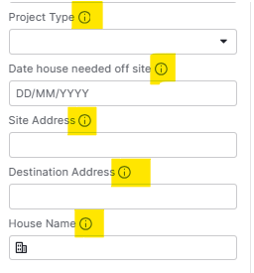

Lead & Project Naming Conventions
Lead Titles are now automated – this is FYI only

Lead Title Naming Conventions | Example
Listings: Site Address | Listing 14 Trilby St, Redcliffe, QLD, 4020
House Sales: House name | Gretchen Cottage
Demolition: Site Address | Demolition 225 Gympie Road, Chermside, QLD, 4032
PR: Site address – Destination Address | Private Relocation 128 Brunswick St, Lismore - 125 McKinnon Rd, Lismore
Raises, Slides: Site Address | Raise/Slide 123 Rode Road, Wavell Heights, Chermside

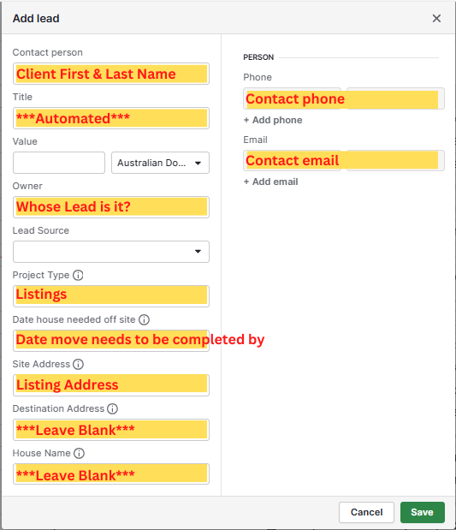
Listings
Mandatory Information:
- First and Last Name
- Phone number
- Email address
- What date do you need the house removed from site? If no date, approx. timeline e.g. within 6 months. (If timeframe is less than 6 months, the house will be assessed for back to yard stock. If not suitable, a demolition proposal will be offered)
- Don’t forget to add notes, transfer ownership (if required) & add an activity

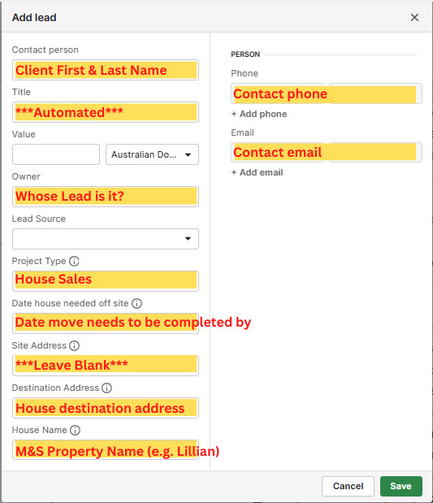
House Sales
- First and Last Name
- Phone number
- Email address
- Project type
- Do you have a block of land settled? (if no please assign activity to Steph to follow up as general enquiry)
- Which house are you interested in purchasing?
- Don’t forget to add notes, transfer ownership (if required) & add an activity

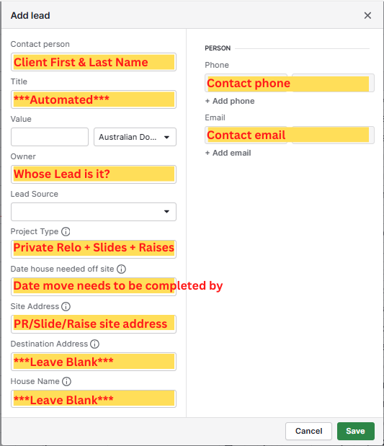
Raise/Slide
- First and Last Name
- Phone number
- Email address
- Project type
- Site Address
- Don’t forget to add notes, transfer ownership (if required) & add an activity

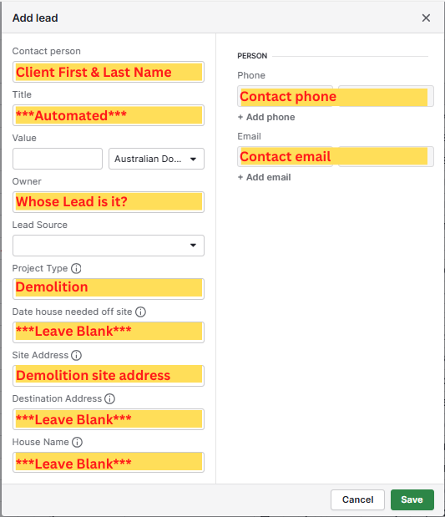
Demolition
- First and Last Name
- Phone number
- Email address
- Project type
- Site Address
- Don’t forget to add notes, transfer ownership (if required) & add an activity

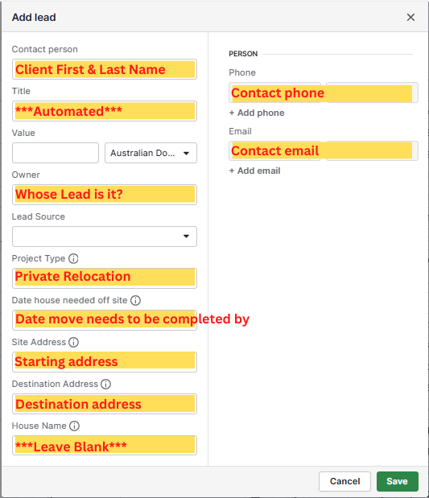
Private Relocation
- First and Last Name
- Phone number
- Email address
- Project type
- Site Address – starting address
- Destination address – finishing address
- Don’t forget to add notes, transfer ownership (if required) & add an activity

Glossary of Terms
Term | Definition
Site Address | The address where the work is taking place. i.e. the site address of the upcoming demolition project is 123 Rode Road, Wavell Heights.
Destination Address | The address where the move will be completed. i.e. the destination address of the house being moved from the yard is 123 Rode Road, Wavell Heights.
House Name | House name as per M&S naming convention. i.e. Lillian, Frank, Esme.
Organisation | Organisation field should only be used when we are directly engaging with the organisation rather than the individual client.

Activity: Create Leads for each Pipeline
Create leads for each Pipeline in Pipedrive using the following information. Please email Kira when this task has been completed.

Listing
Contact Person: Test Kira
Phone: 0449000707
Email: k.lafave@houseremovals.com.au
Address of listing: 123 Rode Road, Wavell Heights

House Sales
Contact Person: Test Kira
Phone: 0449000707
Email: k.lafave@houseremovals.com.au
Address of block of land: 123 Rode Road, Wavell Heights
House customer is interested in: Margo

Demolition
Contact Person: Test Kira
Phone: 0449000707
Email: k.lafave@houseremovals.com.au
Address of site to be demolished: 123 Rode Road, Wavell Heights

Private Relocation
Contact Person: Test Kira
Phone: 0449000707
Email: k.lafave@houseremovals.com.au
Address where house is currently: 123 Rode Road, Wavell Heights
Address where house is to be moved: 456 Gympie Road, Chermside

Raise/Slide
Contact Person: Test Kira
Phone: 0449000707
Email: k.lafave@houseremovals.com.au
Address where the raise/slide will take place: 123 Rode Road, Wavell Heights

Activity: Convert Leads to Deals – COMING SOON
Activity: Convert Deals to Projects – COMING SOON

